**Unlocking Recruitment Efficiency with Artificial Intelligence: 10 Ways to Streamline Your Hiring Process**

**Slide 1: Introduction**

* Welcome and brief overview of ChatGPT.

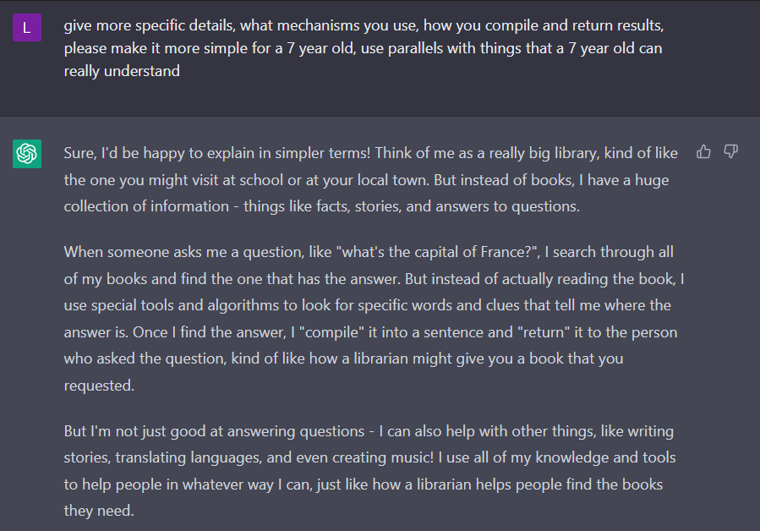

**Slide 2: Create an Interview Question Bank**

* Use case: Generate role-specific interview questions effortlessly.

* Benefits: Timesaving, improved interview approach.

**Slide 3: Candidate Searching**

* Use case: Craft Boolean search strings for candidate sourcing.

Has limitations with X-Ray and requires guidance?

+ Builds X-Ray and Boolean search lines from prompt

* Adding research element to Boolean search for industry mapping.

**Slide 4: Get Keywords for a Job Description**

* Use case: Obtain a list of keywords for effective job description.

Prompt: **“Can you do a Job Description (JD) deconstruction and pull out only the technical stacks to be used to create "Boolean strings" and differentiate the results and replicate the "what do we require" as "Must have" and “What do we desire" as "Good to have". Also, help me find the synonym for the title: Lead Site Reliability Engineer. Here is the data for reference: What do we require?”**

* Enhance search effectiveness with relevant keywords.

**Slide 5: Write Candidate Outreach Copy**

* Use case: Script engaging outreach emails to passive candidates.

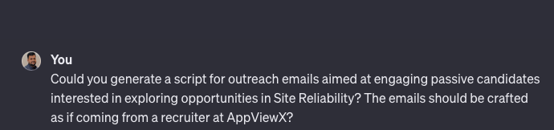

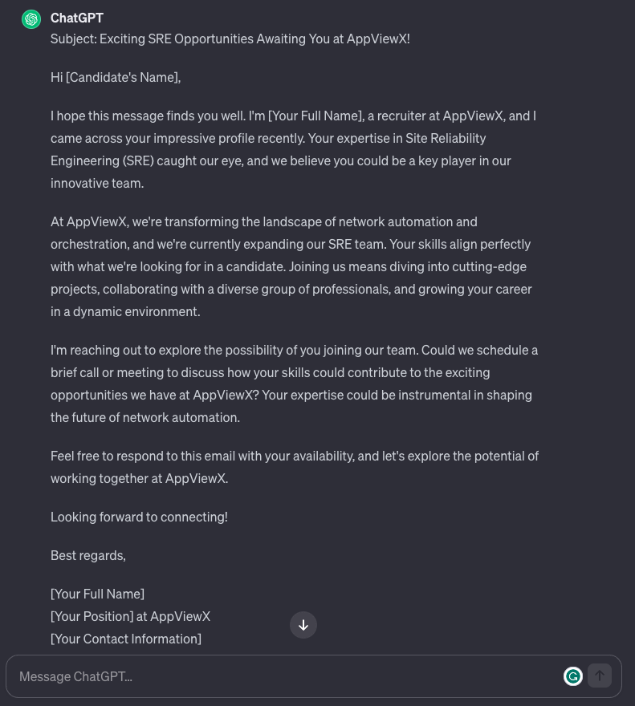

* Benefits: Quick outreach creation with a convincing tone.

**Slide 6: Conduct Hiring Market Research – Use Realtime data platforms like Bard or Perplexity.**

* Use case: Request market outlook for hiring strategy.

* Benefits: Informed and credible insights for strategic planning.

**Slide 7: ChatGPT Prompts for Recruitment Library**

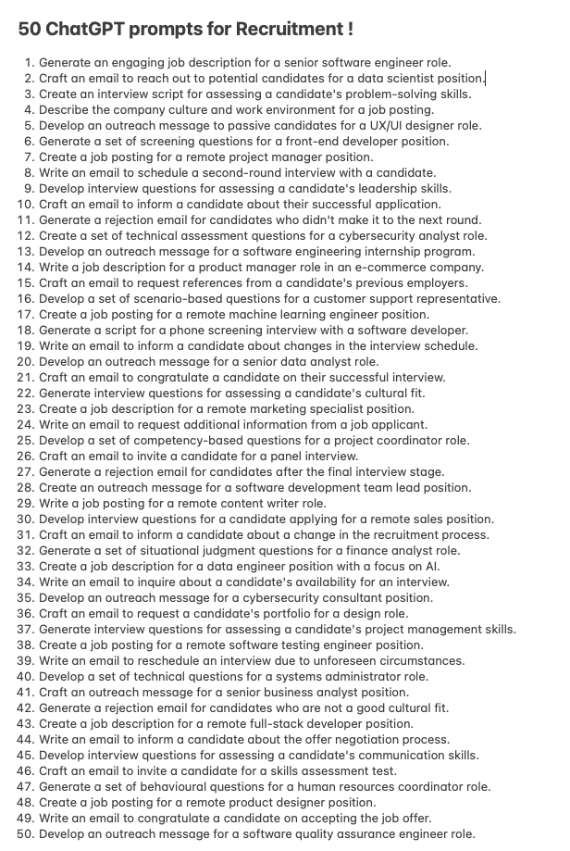

**Slide 8: Create Candidate Summaries**

* Use case: Generate concise candidate summaries from CVs.

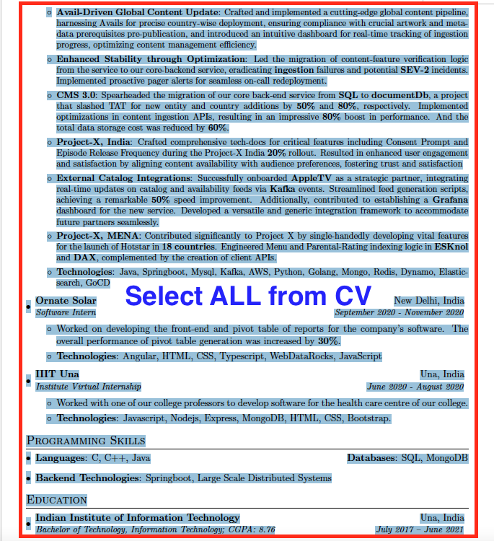

**Prompt:** **Create a profile Summary in 100 words, to be shared to Hiring Manager. + paste the details copied from the CV. >> Press Enter**

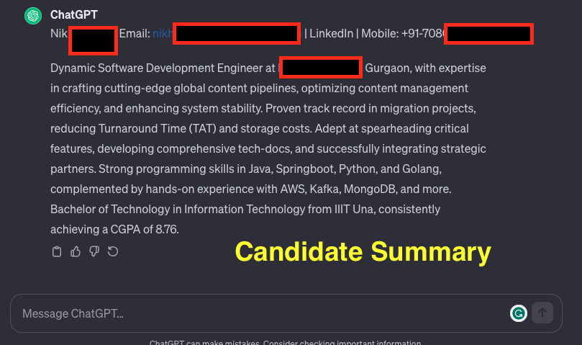

* Benefits: Timesaving in candidate shortlisting process.

**Slide 9: Candidate Assessment – Working Session**

* Use case: Evaluate candidate suitability against job spec.

**Prompt:** Assess the candidate's suitability against the job specification by carefully reviewing their LinkedIn profile in reference to the provided job description. Highlight key skills, experiences, and qualifications that align with the outlined job requirements. Please provide an analysis of how well the candidate's profile meets the specified criteria and note any areas of concern or notable strengths observed during this evaluation.

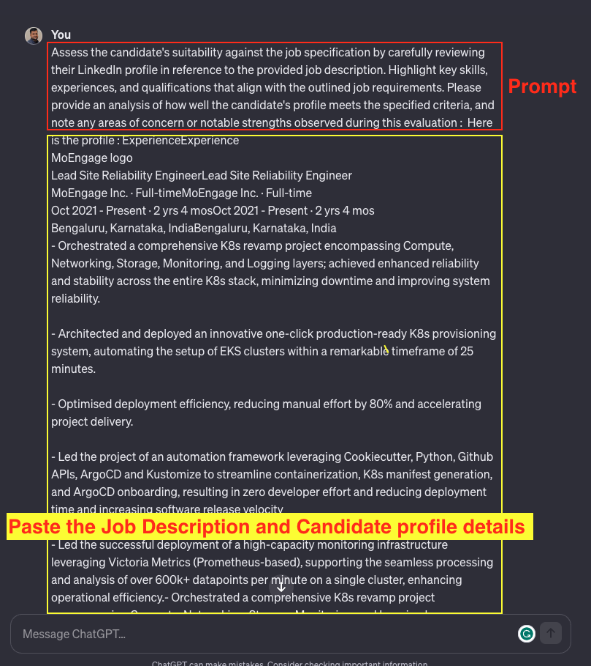

* Benefits: Efficient assessment with pros and cons.

**Slide 10: Candidate Engagement**

* Use case: Respond to candidate inquiries with empathy.
* Example prompt and response.
* Benefits: Enhanced candidate experience with timely and humanistic replies.

**Slide 11: Benefits of ChatGPT for Recruitment**

* Automation of recruitment processes and tasks.
* Improved candidate experience.
* Increased efficiency with high-quality copy templates.

**Slide 12: Challenges of Using ChatGPT for Recruiting**

* Cost considerations.
* Lack of human interaction and potential for bias.
* Encourage careful evaluation before full integration.

**Slide 13: Conclusion**

* Recap key points and use cases.
* Highlight ChatGPT's potential to enhance recruitment efficiency.
* Acknowledge limitations and ongoing developments in the tool.

**Slide 14: Q&A**

* Open the floor for questions and discussions.